Project Report: Personal Website Development
Course : EF234301 Web Programming (D) – Quiz 1
Author : Althea Rahmania Fitri
Student ID : 5025251134
Date : 30 September 2026
1. Design Concepts and Structure
Design Concept
The personal website is built as a single-page application (SPA) designed to showcase two cultural perspectives: Surabaya and Malang.
- Typography: Uses Google Fonts (Fraunces for headings to give an editorial style, paired with Work Sans for clean body text).
- Colour Palette: Styled using CSS custom variables (--primary, --text-muted, etc.) for consistent colour management across components.
- Layout Structure: Flexbox and CSS Grid are used across content blocks and cards to ensure responsive scaling on mobile, tablet, and desktop viewports.
Content Structure & Routing
The URL structure maps to the following single-page anchor sections:
- Homepage (/quiz1): Includes a landing header, introduction, and an interactive typing effect.
- Profile (/quiz1/profile): Displays quick personal facts and a vertical timeline of education history.
- Hometown (/quiz1/hometown): Overview of Surabaya and Malang with embedded Google Maps.
- Local Food (/quiz1/food): A grid-based card layout showcasing regional dishes.
- Tourist Places (/quiz1/tourist): Card grid highlighting regional attractions with external Google references.
2. Implementation & Code Explanation
HTML Architecture
The single-page architecture relies on section identifiers (#home, #profile, #hometown, #food, #tourism). Semantic HTML5 tags (<header>, <main>, <section>, <article>, <figure>, <footer>) are used throughout. Tabbed interfaces use .tabset containers holding .tabs controls and .panel display blocks.
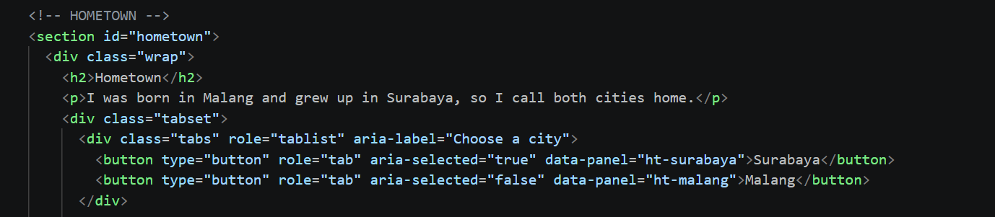

CSS Styling & Panel Toggling
Visibility states are controlled using a CSS utility class .hide:
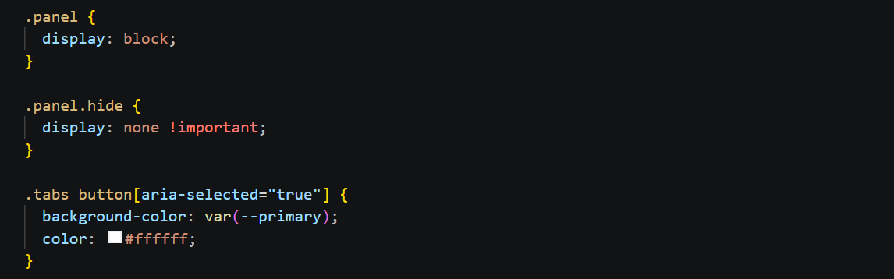
JavaScript Dynamic Functionality (script.js)
- Event Listener for Tabs: Listens for clicks on buttons within .tabs, reads the target data-panel attribute, and attempts to remove .hide from the matching panel ID while adding .hide to inactive panels.
- Typing Animation: Uses JavaScript interval cycles to construct and delete strings dynamically.
- Scroll Progress: Updates the width percentage of #progress relative to the current scroll position.
3. Project Evaluation & Known Errors
Deployment & Routing Evaluation
The project code is hosted on GitHub and deployed to public web hosting. Routing requirements (/quiz1, /quiz1/profile, /quiz1/hometown, /quiz1/food, /quiz1/tourist) are handled through single-page document section routing.
4. Analysis of Known Errors
During testing, one critical issue remains unresolved:
- Unresponsive "Malang" Tab Switching:
  - Description: Clicking the "Malang" tab buttons across the Hometown, Local Food, and Tourist Places sections fails to reveal the Malang content panel properly.
  - Technical Root Cause: The current script matches the button's data-panel attribute to an ID selector via document.querySelector('#' + targetId). Due to DOM caching, scope lookup limitations across multiple identical .tabset structures, or event handling conflicts, the .hide class is not removed as expected.
  - Proposed Fix: Refactoring the script from ID string lookups to index-based sibling toggling (panels[index].classList.remove('hide')) localized strictly within each .tabset parent element.
5. Conclusion
The project successfully implements the visual layout, typography, responsive grid structures, and core content required for Quiz 1. While the interactive tab switching contains a known runtime error where the "Malang" tab fails to display its target panel, the core HTML5 structure, CSS styling, and single-page routing architecture meet the project guidelines.

